Attn. TAUPO DISTRICT COURT
PRIVATE

Re: Notice of intent and claim of right:

- I Monica Eastick will not be attending the TAUPO DISTRICT COURT on the 10th June 2020 because I do not recognise the NEW ZEALAND jurisdiction
- The NEW ZEALAND COURTS use language I do not understand and is far too hoha for me
- I only recognise the Te-Moana-Nui-A-Kiwa Jurisdiction based on my ancestral waka migration and habitat of the islands within Te-Moana-Nui-A-Kiwa
- I am the Tinorangatira of Ngāi Te Rangikoianake hapu that only recognises Tikanga in accordance 1835 He Whakaputanga
- My inherent customary rights to hunt with guns and fish and use tikanga can never be extinguished
- Any unlawful detention by Mercantile Agents will incur the charge outlined in the attached “FEE SCHEDULE”
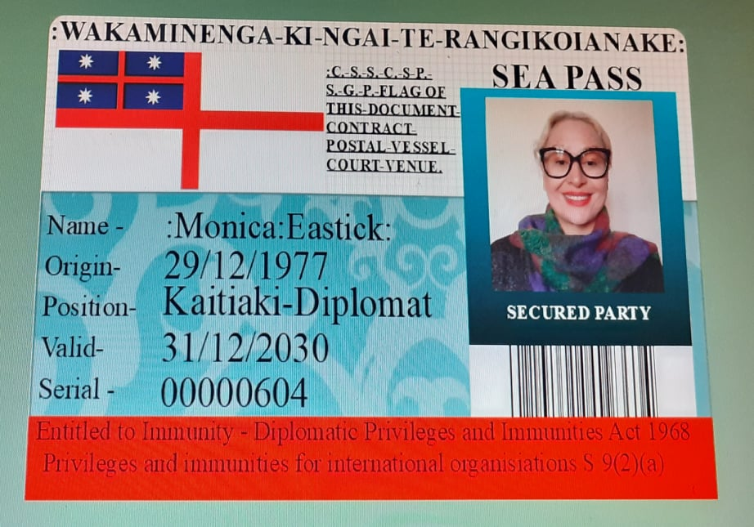
:Monica-Eastick:

Claim of right A belief that an action is lawful. The Crimes Act 1961, s2(1), provides that claim of right, in relation to any act, means a belief at the time of the act in a proprietary or possessory right in property in relation to which the offence is alleged to have been committed, although that belief may be based on ignorance of fact or of any matter of law other than the enactment against which the offence is alleged to have been committed. See Leason v Attorney General [2014] 2 NZLR 224, 229. [MENS REA]

