[Your Name]
[Email address]
[Employer's Name/ Principal / Board of Trustees]
[Address]
[Date]
FOR: [The Manager/ Principal/ Board of Trustees]

COVID-19 – ORDER TO BE VACCINATED AGAINST COVID-19
- Firstly, I refer to my current employment agreement dated [add the date] and [please check your employment agreement before agreeing to the following statement] state that there is no provision within my employment agreement that as a [explain your role or position as per employment agreement] that I must be vaccinated to carry out my role.

- I confirm that I have an obligation to uphold the Treaty of Waitangi. The Treaty states Wakaminenga o nga hapu is the governing body.

- I confirm that my SEA PASS was made by the official Wakaminenga o nga hapu registry known as Te-Moana-Nui-A-Kiwi embassy. Te-Moana-Nui-A-Kiwa Embassy

- I acknowledge that I have diplomatic immunity and will not be forced to take the vaccination or any vaccination and therefore are exempt from all and any acts given by the company being the NZ Government.

- Attached below for reference:

- The Treaty of Waitangi – Te Tiriti o Waitangi New Zealand Treaties Online - Details (mfat.govt.nz).
- Treaty Obligations
- Treaty of Waitangi 1840 - The_Treaty_of_Waitangi.pdf
- United Nations Declaration on the Rights of Indigenous Peoples - UNDRIP_E_web.pdf
- Department of Economic and Social Affairs Indigenous Peoples - United Nations Declaration on the Rights of Indigenous Peoples | United Nations For Indigenous Peoples
- Kupapa Suppression Action 2020.
- New Zealand Bill of Rights Act 1990 - New Zealand Bill of Rights Act 1990 No 109 (as at 01 July 2013), Public Act Contents – New Zealand Legislation

The Treaty of Waitangi - Te Tiriti o Waitangi
Treaty Code:
B1840/04
Treaty Type:
Bilateral/Plurilateral
Common Name:
Responsible Department:
Administering Department:
Treaty Status:
In Force
Treaty Summary:
Applied to New Zealand which subsequently became bound as a successor State
Known as the Treaty of Waitangi and acknowledged as a founding document of New Zealand. As to legal contexts in which it is or has been relevant, a variety of sources can be consulted, including the Treaty of Waitangi Act 1975 and the reports and recommendations of the Waitangi Tribunal constituted thereunder; a number of new Zealand statutes in which the principles of the Treaty are referred to; and appropriate judgements of the High Court (previously Supreme Court) and Court of Appeal of New Zealand. Of particular relevance is New Zealand Maori Council v Attorney-General: (1897) I New Zealand Law Reports 641-719.
The Treaty as signed, however, bore no title. As indicated above, it is known in New Zealand as the Treaty of Waitangi.
NZ Adherence Status:
In Force
Adherence Type:
Definitively signed
Signature Date:
06/02/1840
Adherence Date:
06/02/1840
Expired:
No
Date Concluded:
06/02/1840
Place Concluded:
Waitangi
Entry Into Force Date:
06/02/1840
NZ Entry Into Force Date:
06/02/1840
Termination Date:
Withdrawal Date:
Withdrawal Notification Date:
NZ Objections:
No
NZ Reservations:
No
NZ Declarations:
No
NZ Territorial Applications:
None
NZTS Number:
UNTS Number:
Associated Treaties:
Other References:
29 BSP, 1111;
6 HCT, 579;
89 CTS, 473;
TREATY OF WAITANGI ACT 1975 (NZ), FIRST SCHEDULE;
WAIKATO RAUPATU CLAIMS SETTLEMENT ACT 1995 (NZ), FIRST SCHEDULE.
Treaty Text Link:
Parties:
United Kingdom
Contact Information:
Ministry of Foreign Affairs & Trade | 195 Lambton Quay, Private Bag 18 901, Wellington 5045, New Zealand
Ph +64 4 439 8000, | Email:info@mfat.govt.nz
Treaty Obligations
1. All New Zealand Government Departments have to uphold Te Tiriti O Waitangi 1840 Obligations that bind the State of NZ
2. Forced Vaccinations is a breach of the Te Treaty Obligations
3. Forced Vaccinations is a breach against the BILL OF RIGHTS ACT 1990
Forced Vaccinations is a form of forced assimilation, a crime according to the UNITED NATIONS

All *Native & Indigenous Peoples are protected by these laws and any NZ State Department forcing Vaccines will be ordered to pay financial reparation to all Native & Indigenous complainants upon these islands
*Native Peoples are people born on these islands of Te-Moana-Nui-A-Kiwa
Article 8 1.

Indigenous peoples and individuals have the right not to be subjected to forced assimilation or destruction of their culture. 2. States shall provide effective mechanisms for prevention of, and redress for:

Te Tiriti o Waitangi 1840
KO WIKITORIA te Kuini o Ingarani i tana mahara atawai ki nga Rangatira me nga Hapu o Nu Tirani i tana hiahia hoki kia tohungia ki a ratou o ratou rangatiratanga me to ratou wenua, a kia mau tonu hoki te Rongo ki a ratou me te Atanoho hoki kua wakaaro ia he mea tika kia tukua mai tetahi Rangatira – hei kai wakarite ki nga Tangata maori o Nu Tirani – kia wakaaetia e nga Rangatira Maori te Kawanatanga o te Kuini ki nga wahikatoa o te wenua nei me nga motu – na te mea hoki he tokomaha ke nga tangata o tona Iwi Kua noho ki tenei wenua, a e haere mai nei.
Na ko te Kuini e hiahia ana kia wakaritea te Kawanatanga kia kaua ai nga kino e puta mai ki te tangata Maori ki te Pakeha e noho ture kore ana.
Na kua pai te Kuini kia tukua a hau a Wiremu Hopihona he Kapitana i te Roiara Nawi hei Kawana mo nga wahi katoa o Nu Tirani e tukua aianei amua atu ki te Kuini, e mea atu ana ia ki nga Rangatira o te wakaminenga o nga hapu o Nu Tirani me era Rangatira atu enei ture ka korerotia nei.
Ko te tuatahi (Article 1):
Ko nga Rangatira o te wakaminenga me nga Rangatira katoa hoki ki hai i uru ki taua wakaminenga ka tuku rawa atu ki te Kuini o Ingarani ake tonu atu – te Kawanatanga katoa o o ratou wenua.
Ko te tuarua (Article 2):
Ko te Kuini o Ingarani ka wakarite ka wakaae ki nga Rangitira ki nga hapu – ki nga tangata katoa o Nu Tirani te tino rangatiratanga o o ratou wenua o ratou kainga me o ratou taonga katoa. Otiia ko nga Rangatira o te wakaminenga me nga Rangatira katoa atu ka tuku ki te Kuini te hokonga o era wahi wenua e pai ai te tangata nona te Wenua – ki te ritenga o te utu e wakaritea ai e ratou ko te kai hoko e meatia nei e te Kuini hei kai hoko mona.
Ko te tuatoru (Article 3):
Hei wakaritenga mai hoki tenei mo te wakaaetanga ki te Kawanatanga o te Kuini – Ka tiakina e te Kuini o Ingarani nga tangata maori katoa o Nu Tirani ka tukua ki a ratou nga tikanga katoa rite tahi ki ana mea ki nga tangata o Ingarani.
(signed) William Hobson, Consul and Lieutenant-Governor.
Na ko matou ko nga Rangatira o te Wakaminenga o nga hapu o Nu Tirani ka huihui nei ki Waitangi ko matou hoki ko nga Rangatira o Nu Tirani ka kite nei i te ritenga o enei kupu, ka tangohia ka wakaaetia katoatia e matou, koia ka tohungia ai o matou ingoa o matou tohu.
Ka meatia tenei ki Waitangi i te ono o nga ra o Pepueri i te tau kotahi mano, e waru rau e wa te kau o to tatou Ariki.^{[94]}

In accordance with International Law the Indigenous Translations of Treaties, Conventions and Agreements always take precedence
Highlighted in red writing is the Wakaminenga O Nga Hapu = the Governing Body or Native Autonomous Authority Authority that is recognised by Royal Decree, British Monarch and United Nations
Te-Moana-Nui-A-Kiwa Embassy and the United Nations recognise Wakaminenga O Nga Hapu as the Royal Native Autonomous Authority of 1840 Te Tiriti O Waitangi
Te-Moana-Nui-A-Kiwa Embassy hold the Official National Wakaminenga O Nga Hapu O Nu Tireni registry
New Zealand Government is bound by the Te Tiriti O Waitangi 1840 which is an International Treaty
We thank the New Zealand and Australian Courts for participating in the largest Diplomatic Mission in modern history
Our Diplomatic Mission was designed to strengthen relationships between nations and people, to help Indigenous and Native Peoples of the Pacific and to educate people for the purpose of achieving World Peace

United Nations Declaration on the Rights’ of Indigenous Peoples

Article 8 1.

Indigenous peoples and individuals have the right not to be subjected to forced assimilation or destruction of their culture. 2. States shall provide effective mechanisms for prevention of, and redress for:

(a) Any action which has the aim or effect of depriving them of their integrity as distinct peoples, or of their cultural values or ethnic identities;

(b) Any action which has the aim or effect of dispossessing them of their lands, territories or resources;

(c) Any form of forced population transfer which has the aim or effect of violating or undermining any of their rights;

(d) Any form of forced assimilation or integration;

(e) Any form of propaganda designed to promote or incite racial or ethnic discrimination directed against them. 6

Article 9

Indigenous peoples and individuals have the right to belong to an indigenous community or nation, in accordance with the traditions and customs of the community or nation concerned. No discrimination of any kind may arise from the exercise of such a right.

Article 10

Indigenous peoples shall not be forcibly removed from their lands or territories. No relocation shall take place without the free, prior and informed consent of the indigenous peoples concerned and after agreement on just and fair compensation and, where possible, with the option of return.

Department of Economic and Social Affairs Indigenous Peoples

Top of Form
Bottom of Form
United Nations Declaration on the Rights of Indigenous Peoples

United Nations Declaration on the Rights of Indigenous Peoples
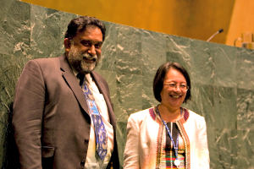
The UN Declaration on the Rights of Indigenous Peoples was adopted by the General Assembly on 13 September 2007
The United Nations Declaration on the Rights of Indigenous Peoples (UNDRIP) was adopted by the General Assembly on Thursday, 13 September 2007, by a majority of 144 states in favour, 4 votes against (Australia, Canada, New Zealand and the United States) and 11 abstentions (Azerbaijan, Bangladesh, Bhutan, Burundi, Colombia, Georgia, Kenya, Nigeria, Russian Federation, Samoa and Ukraine).Click here to view the voting record.
Years later the four countries that voted against have reversed their position and now support the UN Declaration. Today the Declaration is the most comprehensive international instrument on the rights of indigenous peoples. It establishes a universal framework of minimum standards for the survival, dignity and well-being of the indigenous peoples of the world and it elaborates on existing human rights standards and fundamental freedoms as they apply to the specific situation of indigenous peoples.
United Nations Declaration on the Rights of Indigenous Peoples (A/RES/61/295)

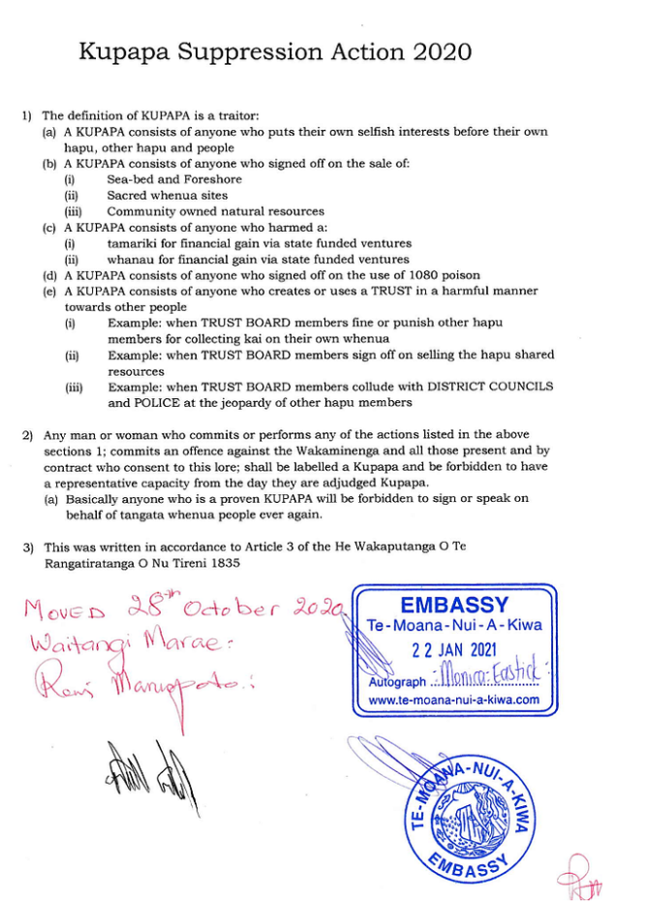

New Zealand Bill of Rights Act 1990
Public Act | 1990 No 109
Date of assent | 28 August 1990
Commencement | see section 1(2)

Note
Changes authorised by section 17C of the Acts and Regulations Publication Act 1989 have been made in this reprint.
A general outline of these changes is set out in the notes at the end of this reprint, together with other explanatory material about this reprint.
This Act is administered by the Ministry of Justice.

Contents
Title
1Short Title and commencement
Part 1
General provisions
2Rights affirmed
3Application
4Other enactments not affected
5Justified limitations
6Interpretation consistent with Bill of Rights to be preferred
7Attorney-General to report to Parliament where Bill appears to be inconsistent with Bill of Rights
Part 2
Civil and political rights
Life and security of the person
8Right not to be deprived of life
9Right not to be subjected to torture or cruel treatment
10Right not to be subjected to medical or scientific experimentation
11Right to refuse to undergo medical treatment
Democratic and civil rights
12Electoral rights
13Freedom of thought, conscience, and religion
14Freedom of expression
15Manifestation of religion and belief
16Freedom of peaceful assembly
17Freedom of association
18Freedom of movement
Non-discrimination and minority rights
19Freedom from discrimination
20Rights of minorities
Search, arrest, and detention
21Unreasonable search and seizure
22Liberty of the person
23Rights of persons arrested or detained
24Rights of persons charged
25Minimum standards of criminal procedure
26Retroactive penalties and double jeopardy
27Right to justice
Part 3
Miscellaneous provisions
28Other rights and freedoms not affected
29Application to legal persons
Reprint notes

An Act—
- (a)to affirm, protect, and promote human rights and fundamental freedoms in New Zealand; and
- (b)to affirm New Zealand's commitment to the International Covenant on Civil and Political Rights

Conclusion
6 . Finally, at this point in time, and in these current circumstances, I will not give my full consent to undergo any medical procedure. In regard to the vaccination/injection itself, based on the facts and information as stated above.
7. Furthermore, I confirm that I am willing and able to carry out and perform my role of employment as per my contract.

Sincerely,
[Your Name]
[Your contact details]

